-------------------------------------------------------------------------------------------------------------------------------NAME: ARCHANA DEVI.P
REG NO: 192521192
COURSE: SOFTWARE TESTING
CODE: CSA0923
LAB PROGRAMS
Question 22: Reverse a Number Using Junit

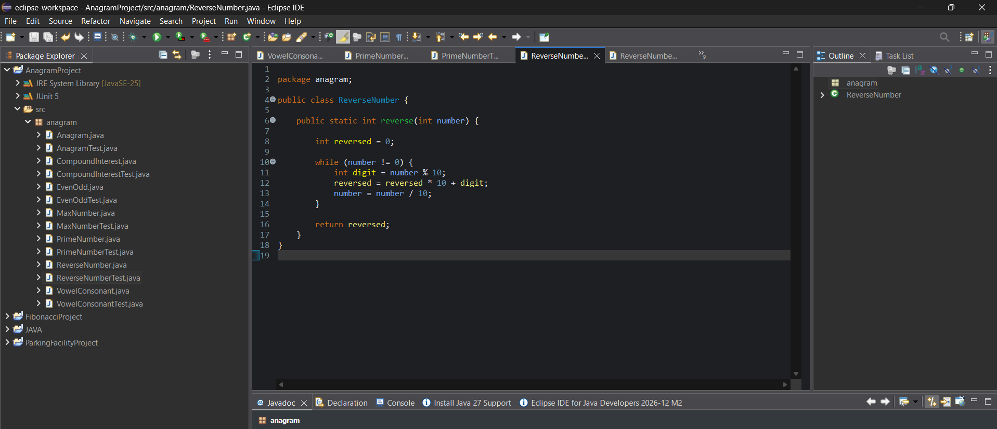

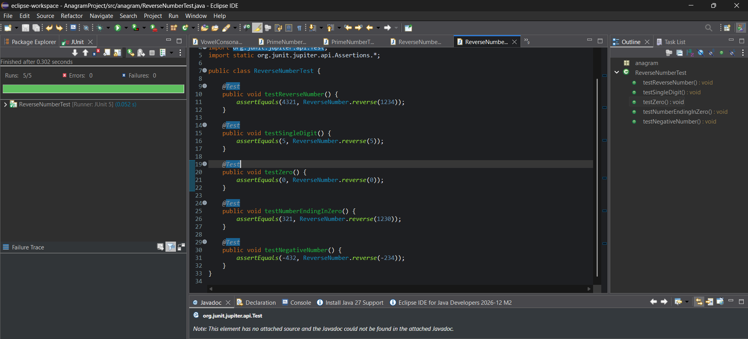
White-box testing
The test cases cover:
- The loop executing multiple times.
- A single-digit number.
- Zero, where the loop does not execute.
- A number ending in zero.
- Negative input.
Result for your record: The number-reversal program was implemented and validated using JUnit assertions. Five test cases verify the different execution paths of the loop.

